Question : 1
Given two 2x2 matrices representing the number of likes and comments on two Instagram posts over two days, write Python code to multiply them and display the resulting matrix :

import numpy as np
likes = np.array([
[100,150],
[200,250] ])
comments =np.array([
[10,15],
[20,25] ])
result =np.matmul(likes,comments)
print("Resulting Matrix:")

print(result)
Question : 2
Create a simple Python function linear_regression_predict(x, m, c) that takes an input value x, slope m, and intercept c, and returns the predicted output y for a linear regression equation y = mx + c :

def linear_regression_predict(x, m, c):
y = m * x + c
return y
print (linear_regression_predict(5,4,10))


Question : 3
Imagine you are predicting the delivery time for Zomato orders based on distance. Given three distances (2km, 5km, 8km) and a linear regression equation y = 4x + 10 (where y is minutes), use your function from the previous task to calculate the predicted delivery time for each distance :
- Equation: y = 4x + 10
- Distances: 2 km, 5 km, 8 km
def linear_regression_predict(x,m,c):
return m * x + c
distances =[2,5,8]
for distance in distances:
predicted_time =linear_regression_predict(distance,4,10)
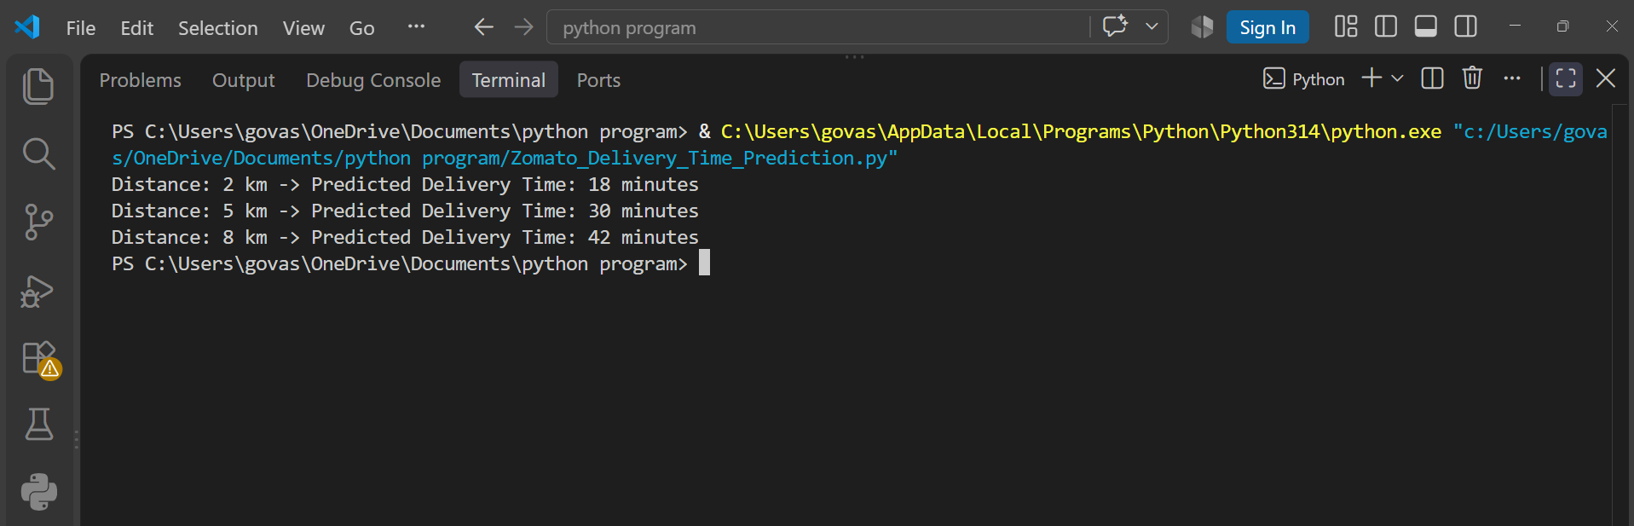
print(f"Distance:", distance,"km -> Predicted Delivery Time:", predicted_time,"minutes")
So, as distance increases the predicted delivery time also increases.

Question : 4
Explain in your own words what the slope and intercept represent in the context of Flipkart's product price prediction (e.g., predicting price based on product rating). Write 2-3 sentences for each term :

- Slope and Intercept in Flipkart Price Prediction :

“ The slope tells us how much the predicted product price changes when the product rating increases by 1 unit. For example, if the slope is ₹500, the predicted price increases by ₹500 for every 1-point increase in rating. ”

“ The intercept is the predicted product price when the rating is 0. It represents the starting/base price of the model before considering the effect of the product rating. ”

Question : 5
Use ChatGPT to ask: 'How does matrix multiplication help in training a machine learning model like Spotify's song recommendation system?' Summarize the answer in your own words in 3-4 sentences :

Matrix multiplication can help Spotify connect users with songs based on their listening behavior.
Users and songs can be represented as numerical vectors or matrices containing information about preferences and song features.
Multiplying these matrices helps calculate how strongly a user may like different songs.
The recommendation system can then use these scores to suggest songs that the user is likely to enjoy.

